**Discussion 8 - 2**

*Prompt 1*

Compare and contrast these two ways of showing changes in tech company stock prices, which is taken from Claus Wilke’s data visualization book. For both the left and right hand side approaches, consider:

* For which audiences is it more vs. less effective?
* Which communicates a clearer story?
* How do they relate overviews with details?

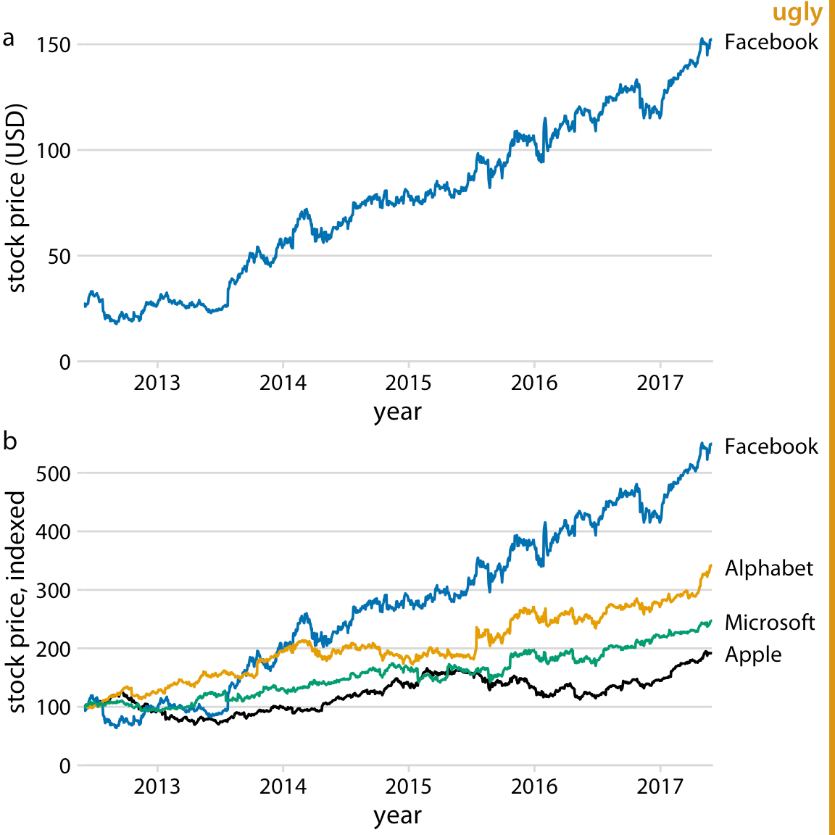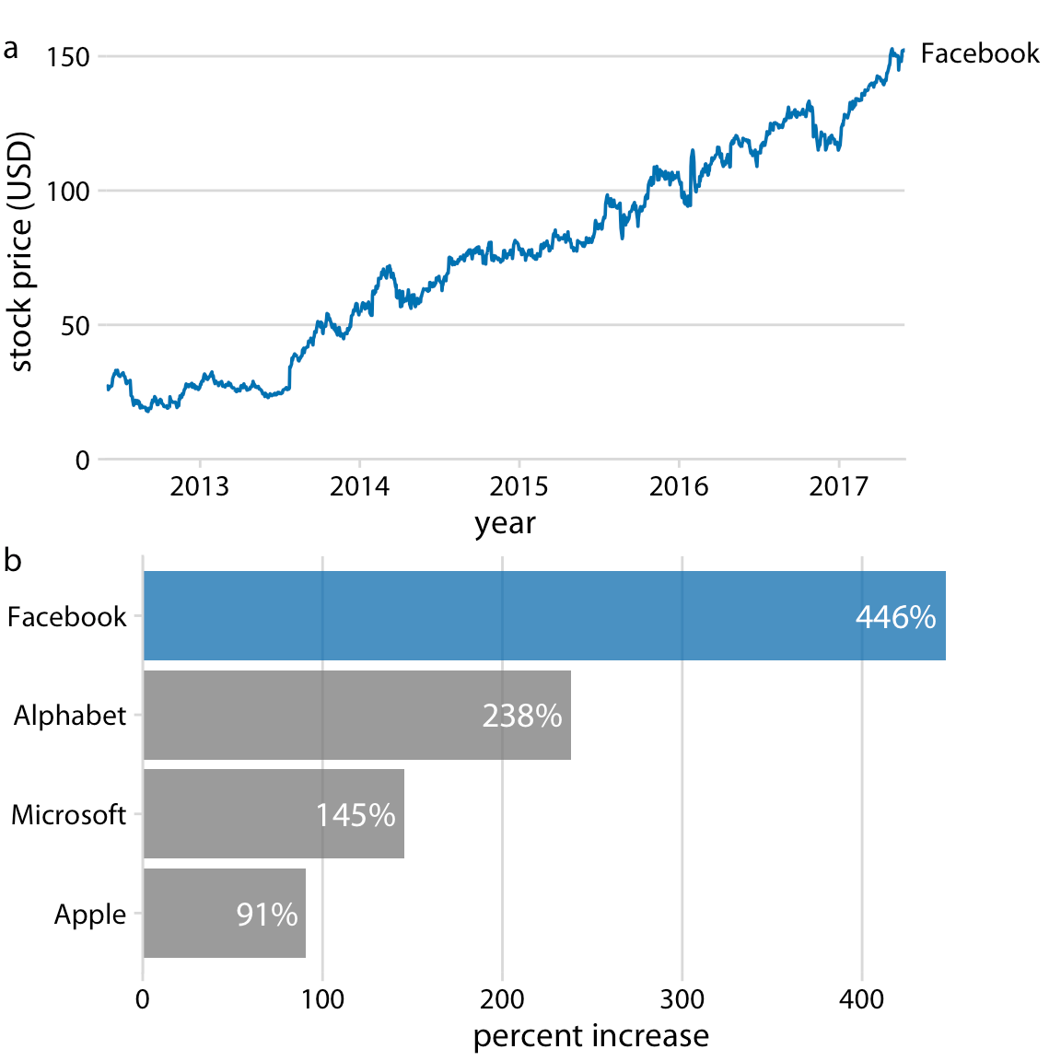

*Prompt 2*

* Is there a concept / code example from the notes / lectures that you would like to go through in more detail?
* Is there a simplified example that would be helpful to work through?

**Responses**